YEAR 9 SCIENCE
PHYSICAL SCIENCES
INVESTIGATION - ABSORPTION + RADIATION

Background

All objects above absolute zero (-273.15 °C) contain heat energy. This is seen as internal energy made up of the kinetic and potential energy of the particles in an object.

The amount of heat within an object is determined by the type of material with which it is made. Each material is unique in its ability to absorb and radiate heat.

Absorbing heat will lead to a temperature increase, while radiation of heat leads to a temperature decrease.

Task

Your task is to determine the effect of colour on the ability to absorb and radiate heat.

Method

The following diagram gives some information on how to investigate the absorption of heat. The wire gauze will glow red hot, providing the heat source for this part of the investigation.

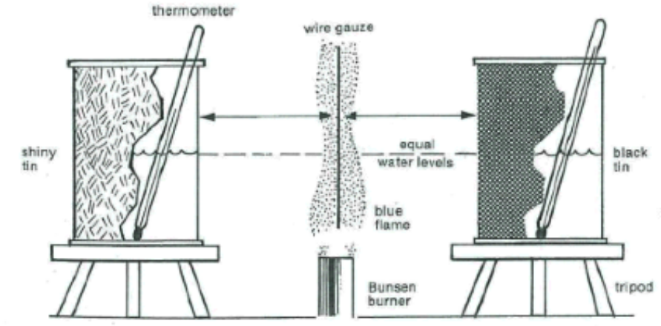

You will need to decide on a suitable method for the investigation of radiation of heat, which will lead to the water cooling in each can.

Apparatus

Black and silver can.
Tripods.
Bunsen burner.
Gauze wire mat.
Retort stand with boss head and clamp.
Hot water from a kettle.
Thermometer.
Small beaker to transport hot water.

Write up

An investigating scaffold has been provided for you to do the write up. Remember to display your data correctly in a table and draw a suitable graph. It is possible to show both sets of data on the same graph.

